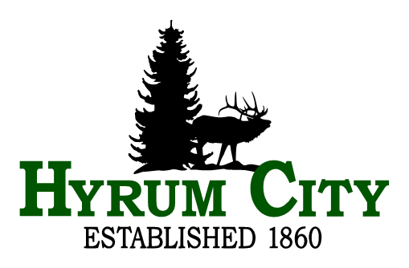

|  |
| --- |
| **career opportunity** |

**WATER & IRRIGATION Superintendent**

Annual Salary Range: $70,472 Min - $86,080 Mid - $101,647 Max. *Hiring salary is between Minimum and Mid depending on experience.*

Hyrum City is seeking a Water & Irrigation Superintendent for its municipally owned and operated Culinary Water and Pressurized Irrigation Department. The Water & Irrigation Superintendent is responsible for the day-to-day management and operations of the utility.

The Water & Irrigation Superintendent performs a variety of managerial, administrative, project management and field supervisory duties related to planning, organizing, directing, and coordinating the construction and maintenance of the city’s culinary water distribution infrastructure, and secondary pressurized irrigation system delivery maintenance and infrastructure.

Hyrum City Culinary Water and Pressurized Irrigation Departments operates with an annual budget of approximately $3.5 million. The Water and Irrigation Superintendent leads a staff of three.

The Water and Irrigation Superintendent for Hyrum City will (see complete job description at [www.hyrumcity.com](http://www.hyrumcity.com)):

* Provides high quality, senior executive leadership to encourage innovation within the City that results in a modern government responsive to residents and businesses.
* Have considerable knowledge of culinary water and pressurized irrigation production and delivery; design and analysis; purification and sanitation; and knowledge of contract development and administration.
* Oversees and performs water system maintenance. Excavates and repairs water leaks, installs new water mains and services as needed along with scheduling leaks being fixed and prioritizing workload to operators and technicians., thaws frozen pipes, and maintains wells and water chlorination system.
* Have skills in planning, directing, and managing the overall operations of a municipal culinary water utility, including developing/implementing policies and procedures, determining rates, and preparing and monitoring the budget, and preparing reports.

Required Education and Experience:

Education: Graduation from High School; AND Experience: Eight (8) years of experience performing the above or closely related duties with two (2) years of daily management and on-site charge; OR Any equivalent combination of education and experience with a minimum of two (2) years of culinary water management.

Compensation and Benefits:

Hyrum City offers the following comprehensive benefit package:

Utah State Retirement

Health & Dental Insurance – Traditional Plan City pays 82% of premium.

Life Insurance

Long Term Disability

Leave Pay – Holiday, Vacation, Short Term and Long Term Sick

Application and Selection:

Send a cover letter and resume to Hyrum City Corporation, 60 West Main, Hyrum, UT 84319 or e-mail to sfricke@hyrumcity.com. Resumes are accepted until position is filled by a qualified candidate or withdrawn at the City’s discretion. A copy of the full position description is available at www.hyrumcity.org EOE. *Upon employment employee must reside in Hyrum City or no further than fifteen miles from city office.*

If you have questions, please contact Human Resources at sfricke@hyrumcity.com or 435-245-6033.

Dated: June 18, 2024