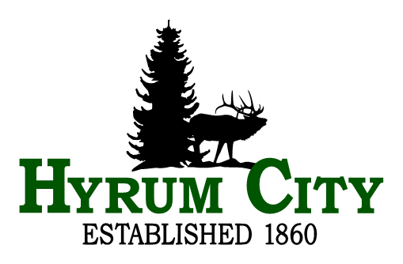

career opportunity

City planner

Annual Salary Range: $59,171 Min - $73,964 Mid - $81,960 Max. Hiring salary is between Minimum and Mid depending on experience.

Hyrum City is seeking a City Planner to perform a variety of professional and technical duties as needed to plan, organize, direct, and coordinate the daily operation of the Planning and Zoning Division.

The City Planner will oversee the development and implementation of the City’s General Plan and other comprehensive current and long range master planning. Monitors community compliance with established planning, zoning, and development ordinances and ensures Hyrum City is compliant with State Laws related to municipal land use regulation. Assists with planning, organizing, and coordinating city wide economic development.

The City Planner for Hyrum City will (see complete job description at www.hyrumcity.com):
- Reviews application requests and development plans for site plans, conditional use permits, re-zoning to monitor community compliance with the city’s General Plan, and other city policies.
- Meets with the general public, developers, staff, etc. to answer and discuss planning, zoning, and development issues.
- Conducts field research on issues, policies, and concepts pertaining to planning, zoning, and community development, presents findings to Planning Commission and City Council, and prepares written reports in response to public requests for zoning applications and various ordinance changes.
- Prepares and updates all city mapping including, zoning, annexations, trails, long range master plan, street, parks, etc.
- Participates in public meetings, prepares and makes presentations to the Planning Commission and City Council relating to development applications, conditional use permits, code amendments, etc.

Required Education and Experience:
Education: Graduation from college with a bachelor’s degree in urban planning, geography, public administration, or a closely related field; AND Experience: Four (4) years of progressively responsible experience performing above related duties; OR Any equivalent combination of education and experience.

Compensation and Benefits:
Hyrum City offers the following comprehensive benefit package:
Utah State Retirement
Health & Dental Insurance – Traditional Plan City pays 82% of premium.
Life Insurance
Long Term Disability
Leave Pay – Holiday, Vacation, Short Term and Long Term Sick

Application and Selection:
Send a cover letter and resume to Hyrum City Corporation, 60 West Main, Hyrum, UT 84319 or e-mail to sfricke@hyrumcity.com. Resumes are accepted until position is filled by a qualified candidate or withdrawn at the City’s discretion. A copy of the full position description is available at www.hyrumcity.org. EOE. Upon employment employee must reside in Hyrum City or no further than fifteen miles from city office.

If you have questions, please contact Human Resources at sfricke@hyrumcity.com or 435-245-6033.

Dated: June 18, 2024

